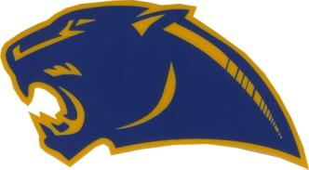
Dear Parent(s):

BIRCH RUN HIGH SCHOOL BASEBALL

Your son is a prospective player for the Birch Run Baseball Team. If he were to become a player on the team, I would like to give you some information you will need so that you may plan ahead.

March, 22-23, 2021 Tryouts Pitchers and Catchers - 4:45 p.m. – 6:00 p.m.
Infielders - 6:00 p.m. – 7:30 p.m.
Outfielders – 7:30 p.m. – 9:00 p.m.

March 24, 2021 First Day of Practice

March 26, 2021 Team Fees due (price detail below)

March 29, 2021 Spring Break ( there will be practice during
the break)

April 6, 2021 First Game (Varsity plays @Home, JV plays
away)

April 16, 2021 First Game for Freshmen

May 1, 2021 Big Cat Classic

May 5, 2021 Picture Day - 4:00 p.m.

May 19, 2021 Senior Nite
PARENTS OF All SENIORS PLEASE
ATTEND

May 23, 2021 BRAA golf outing (please support!)

Team Packages:
All Players - $160.00
(includes: one (1) hat, two (2) t-shirts, two (2) polo shirts, hoodie, shorts, and socks

Uniforms
All players must wear royal blue undershirts and royal blue socks with their uniforms.( No exceptions!!!).
(Cleats must be royal blue)

Spirit Wear: Sandlot Sports: will send linked for the store.

Game Day Attire: Polos and dress pants (MANDATORY)

Birch Run Baseball handbooks will be given to players so parents can sign.

If you have any questions, please feel free to contact me. Go Panthers!

Coach Billy Cork
(989) 928-7131

